Student’s Name
Professor name
Course code and name
Institution
Date
Question one: What are the four significant categories of printmaking? How do they differ? For what purposes were prints traditionally used? Include one example of a traditional printmaker, describing what it is about their process and subject matter that makes them traditional. Then give an example of at least one artist who began to use prints in new ways, explaining why and how they did so. Consider techniques, printing processes, states, and the concept of "limited" editions. Be sure to include a captioned image for each example.

Printmaking entails the process is producing artworks through printing, usually on a paper. It involves generating prints with originality elements instead of taking the course of photographic reproducing of a painting. The prints are crafted via copying ink selected in a given matrix and spread to a sheet of paper as well as other objects through numerous techniques. The matrixes commonly utilized are the metal plates such as copper or zinc and polymer platers as well as other thicker plastic sheets used for engravings or etching.
Printmaking is classified into four major categories that stencil, planographic, intaglio as well as relief. The relief technique involves the ink being spread onto original sheet on the matrix. Some examples of relief techniques include the Asian forms such as woodcut, linocut, wood engraving as well as metal cut. The Intaglio technique involves ink being applied beneath the original surface of the given matrix. Examples of the method include engravings, etching, mezzotint alongside aquatint. The planographic process consists of the matrix retaining on its original surface despite specially designed to allow for movement of the image. Examples of this technique include lithography, monotyping alongside other digital methods. Lastly, the stencil technique involves either ink or even the paint being pressed via a designed screen. Examples include the screen printing as well as pochoir.
The relief process is the oldest method, simplest and relatively cheap compared to the other techniques since no mechanical press or numerous implements are adopted. When generating a woodcut, the artist only makes a drawing using black ink or marker on a primed wooden plank. The Intaglio method is also not a complicated technique and does not require any particular skill but uses some tools for cutting such as a sharp object such as a needle to make lines onto the metal plate typically covered with grounds consisting of wax, resin and black pigment all that resist acid (Stijnman 2).
Traditionally, the printmaking was used as a form of communication. For long, printmaking is a valued artistic medium that adapted unique technical qualities. When the artists want to pass a point in the society, they will create an image on a flat surface, which is then inked and after that placed onto a paper to generate an original print with artists' intended message. The Mesopotamia and Persians used the prints such as cylinder seals to certify documents written in clay (Keehn 1).
Rembrandt van Rijn is a traditional printmaker who was a great innovator as well as an experimenter in this medium and frequently utilized the traditional materials in unique ways to generate prints. Rembrandt had a portfolio of 300 etchings and drypoints from 1626 t0 1665. The artists who began printmaking for the contemporary world is Jan Vermeer. This is because there contain multiples that contradict the artwork, paints; hence his work is considered as a secondary medium. The artists also adopted the used printer’s ink to the oil paint, vanish glazes, linocut, wash, linocut among others (Suzuki 6).
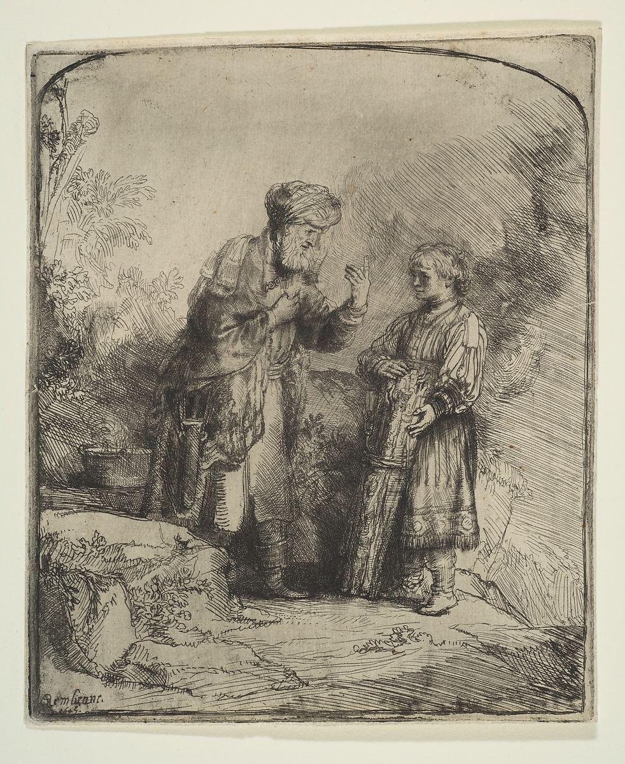
Abraham and Isaac

Source: https://collectionapi.metmuseum.org/api/collection/v1/iiif/343139/764762/main-image

Christ presented to the people.
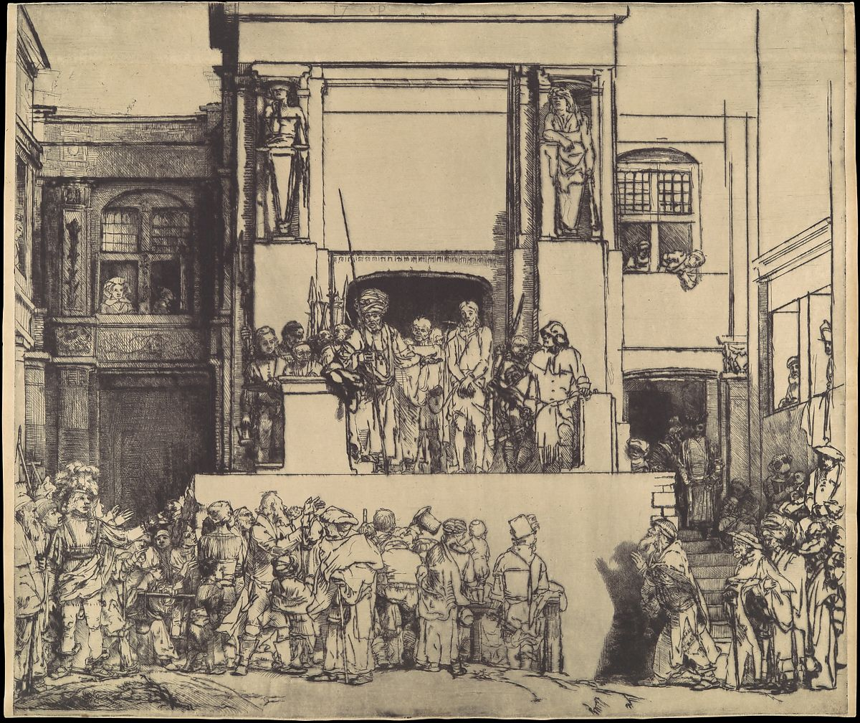
Source: https://www.metmuseum.org/art/collection/search/343142

Work cited
Keehn, Nancy. "Printmaking: a phenomenological art." (1972).
Stijnman, Ad. Engraving and Etching, 1400-2000: A History of the Development of Manual Intaglio Printmaking Processes. Brill Hes & De Graaf, 2012.
Suzuki, Sarah. "Print People: A Brief Taxonomy of Contemporary Printmaking." Art Journal 70.4 (2011): 6-25.

